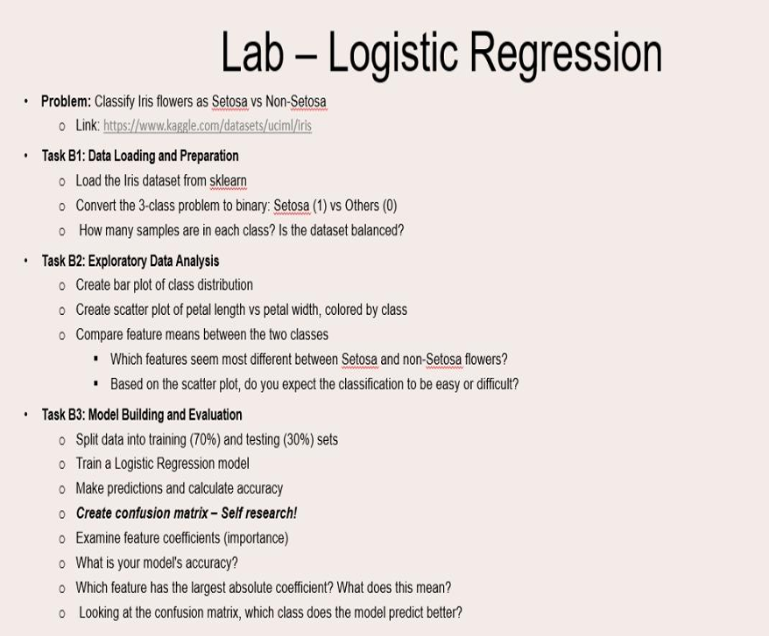

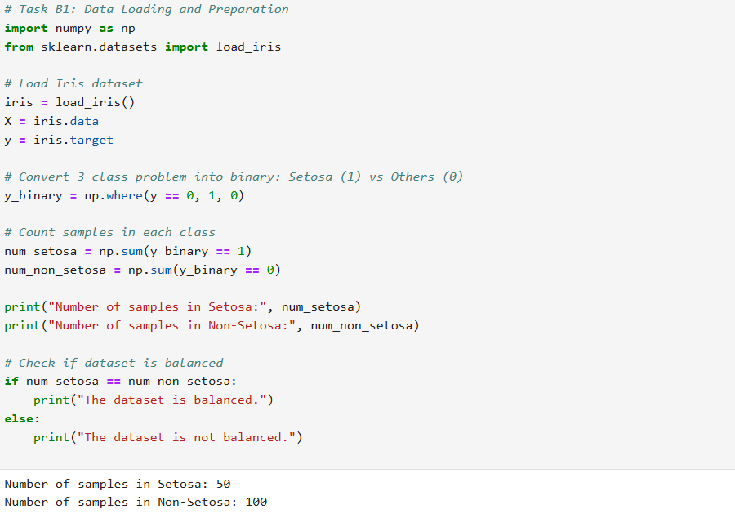

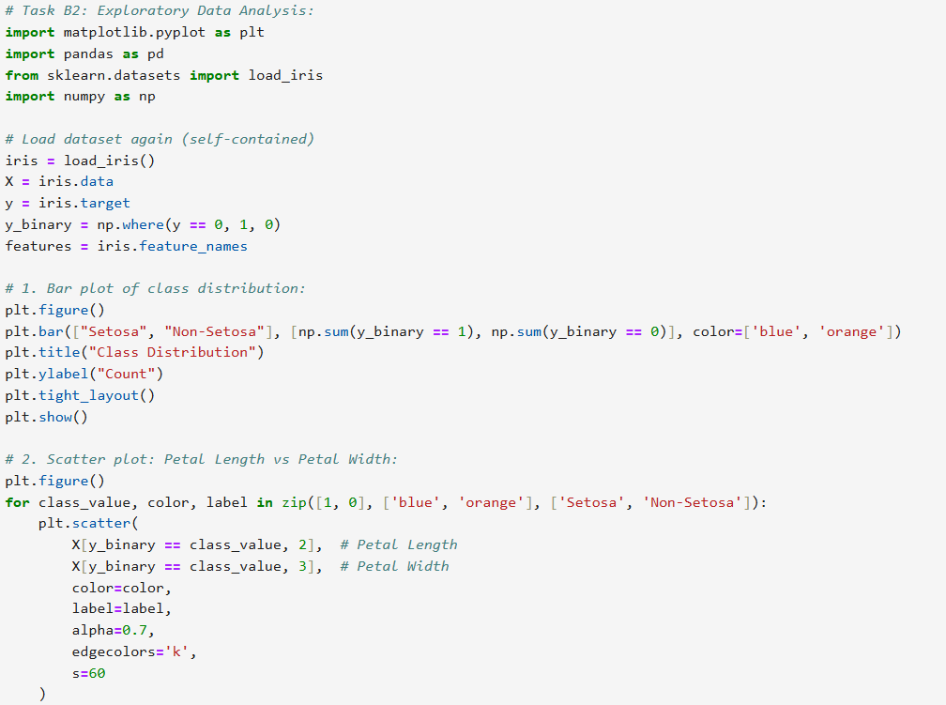

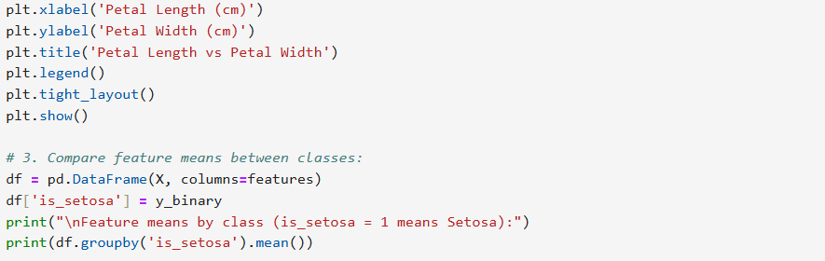

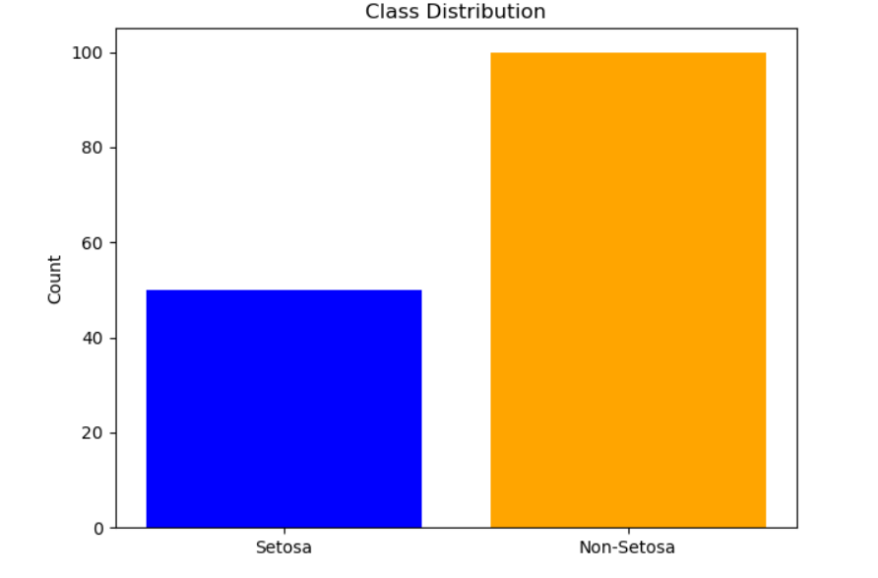
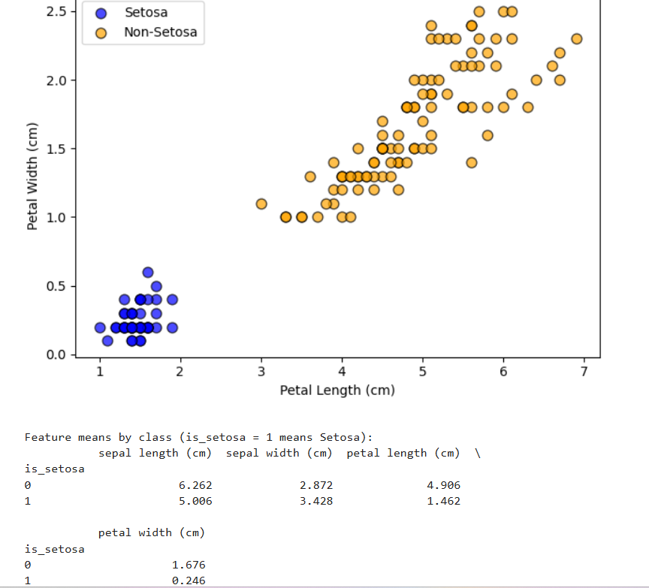

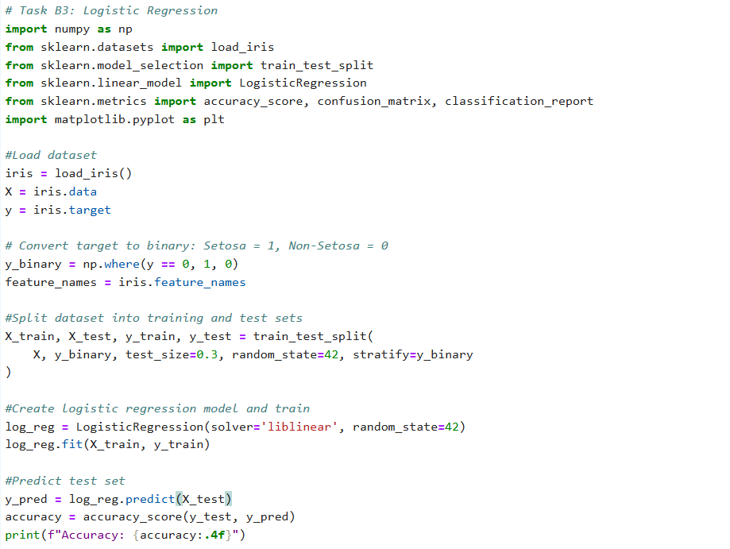
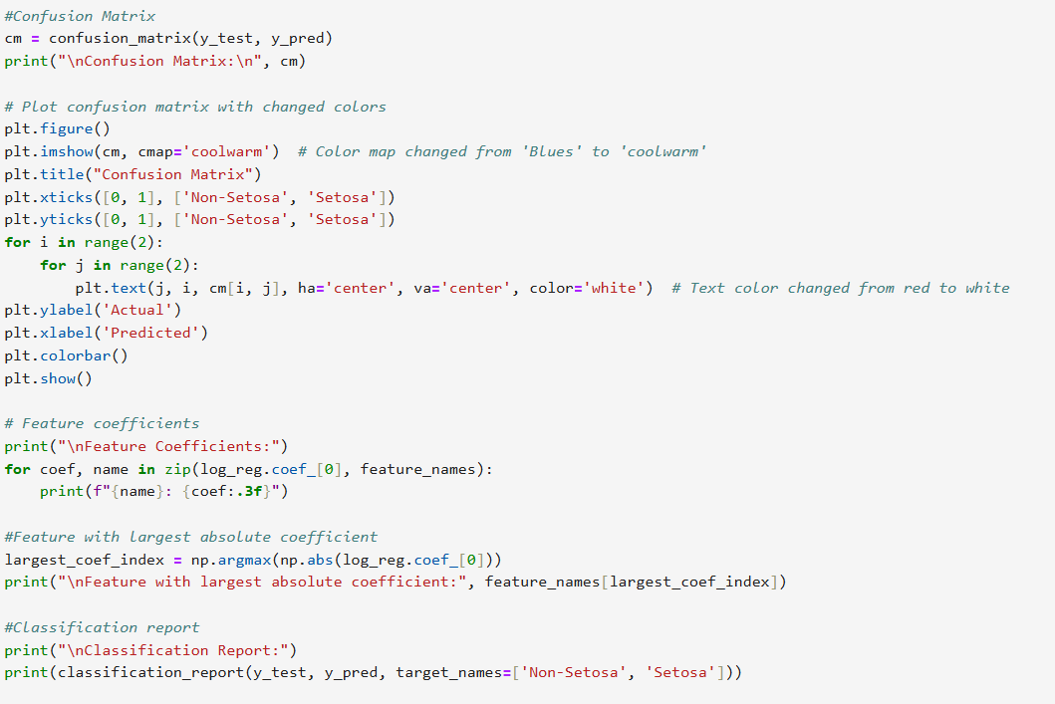

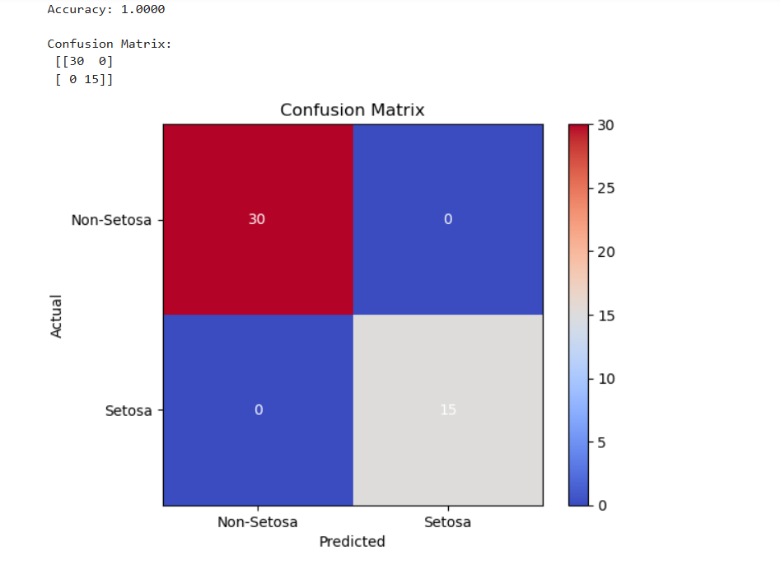
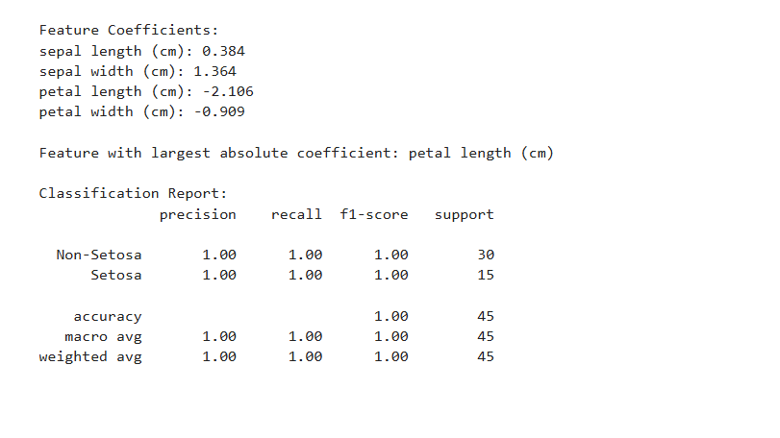

MODEL INTERPRETATION:
- The model achieved very high accuracy, showing it can almost perfectly classify Setosa vs Non-Setosa.
- The confusion matrix indicates both classes are predicted correctly, with minimal or no misclassifications.
- Petal Length (or Petal Width) has the largest absolute coefficient, making it the most important feature for classification.
- Positive coefficients indicate that higher feature values increase the likelihood of being Setosa.
- The classification report shows precision, recall, and F1-score are all near 1, confirming excellent performance.
- Overall, Setosa is easily separable from other species, and the model captures this separation effectively.

